TS

CS-114 - Fundamental of Programing

Lab Manual # 02

Course Instructor: Dr Jawad Khan

Lab Instructor: Muhammad Affan

Student Name: TAHA MUZAMMIL RASOOL
CMS ID: 456279

DATE:

Lab Manual # 02
Variables, constants and data types

Objective:
This lab is about familiarization with different data types, developing understanding of variables and constants taking input from user, showing output to screen and writing simple programs.

Description:

Variables
Variables are the names you give to computer memory locations which are used to store information to be referenced and manipulated in a computer program.

Creating variables
Creating variables is also called declaring variables in C++ programming.
#include <iostream> using namespace std;
int main() { int a; int b;
}

The above program creates two variables to reserve two memory locations with names a and b using int keyword to specify variable data type which means we want to store integer values in these two variables. Similarly, you can create variables to store float, char or any other data type.
For example –
/* variable to store char value */ char a;
/* variable to store float value */
float b;
Store Values in Variables:

  int main() { int a; int b; a = 10; b = 20;
  }
  in main(){
  int a = 10;
  int b = 20;
  }

Get input from user
The cin object in C++ is an object of class istream. It is used to accept the input from the standard input device i.e. keyboard. It is associated with the standard C input stream stdin.

#include <iostream> using namespace std;
int main() { int a, b, sum;
cout<<”Enter first number”<<endl; cin>>a;
cout<<”Enter second number”<<endl; cin>>b; sum = a+b;
cout<<”Addition of two number is:”<<sum<<endl;
}

C++ Datatypes
A variable in C++ must be a specified data type. The data type specifies the size and type of information the variable will store:

Data |  |  | Type Size |  | Description
int |  |  |  | 4 bytes | Stores whole numbers, without decimals
float |  |  |  | 4 bytes | Stores fractional numbers, containing one or more decimals. Sufficient for storing 7 decimal digits
double |  |  |  | 8 bytes | Stores fractional numbers, containing one or more decimals. Sufficient for storing 15 decimal digits
boolea |  |  | n | 1 byte | Stores true or false values
char |  |  |  | 1 byte | Stores a single character/letter/number, or ASCII values

Example:
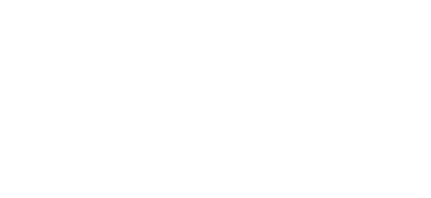
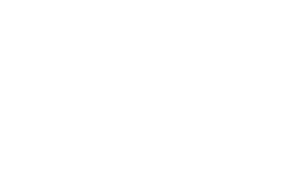
int myNum = 5; float myFloatNum = 5.99; double myDoubleNum = 9.98; char myLetter = 'D'; bool myBoolean = true; string myText = "Hello";
// Integer (whole number)
// Floating point number
// Floating point number
// Character
// Boolean
// String

Defining Constants
There are two simple ways in C++ to define constants − • Using #define preprocessor.
• Using const keyword.

The #define Preprocessor
Following is the form to use #define preprocessor to define a constant − #define identifier value

#include <iostream> using namespace std;

#define LENGTH 10
#define WIDTH 5
#define NEWLINE '\n'
int main() { int area;
area = LENGTH * WIDTH; cout << area; cout << NEWLINE; return 0;
}

The const Keyword
You can use const prefix to declare constants with a specific type as follows − const type variable = value;
#include <iostream> using namespace std;
int main() { const int LENGTH = 10; const int WIDTH = 5; const char NEWLINE = '\n'; int area;
area = LENGTH * WIDTH; cout << area; cout << NEWLINE; return 0;
}

Lab Task:
- Write a C++ code that displays your name, department and degree on the console. Make sure the three things are in three different lines.
- Write a C++ code that takes two numbers and displays the addition, subtraction, division, multiplication and square of given numbers, on the console window. Make sure to comment your code.
- Write a code in C++ that takes radius of a circle as input from user and outputs the circumference and area. The output should be clear and readable. Add proper comments to the code. You can set the value of π up to 3 decimal places.
- Write a C++ code that prints out the following sequence: 0, 1, 1, 2, 3, 5, 8, 13 using three variables.

Home Task:

- Write a C++ program to calculate distance between two points. The values should of coordinates should be input by user.
- Write a code in C++ to take length from user in centimeter and convert it into meter and kilometer.
- Write a code in C++ that takes values of a and b from the user and displays result of polynomial
𝑎2 + 2𝑎𝑏 + 𝑏2.
- Write a program in C++ to convert temperature in Fahrenheit to Celsius.

TASK 1
#include<iostream>
using namespace std;
int main()
{
double x1,x2,y1,y2,distance;
cout<<"enter x coordinate of first point";
cin>>x1;
//x1 is the x coordinate of first point
cout<<"enter y coordinate of first point";
cin>>y1;
//y1 is the y coordinate of the first point
cout<<"enter x coordinate of second point";
cin>>x2;
//x2 is the x coordinate of the second point
cout<<"enter y coordinate of second point";
cin>>y2;
//y2 is the y coordinate of the second point
distance=(x2-x1)*(x2-x1)+(y2-y1)*(y2-y1);
// this is the distance between two given points
cout<<"the distance between the two points is"<<distance;

}
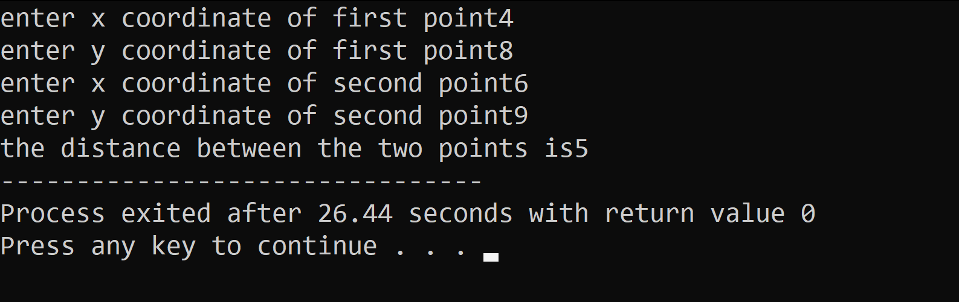

TASK 2
#include<iostream>
using namespace std;
int main()
{
double cm,m,km;
cout<<"enter centimeters";
cin>>cm;
//value taken as input in centimeters
m=cm/100;
km=cm/100000;
cout<<"meters="<<m<<endl;
//value converted to meters
cout<<"kilometers="<<km;
//value converted to kilometers
return 0;

}
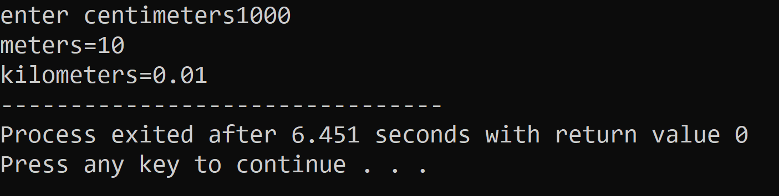

TASK 3
#include<iostream>
using namespace std;
int main()
{
double a,b,polynomial;
cout<<"enter value of a";
cin>>a;
//a is the value of first numberentered by the user
cout<<"enter value of b";
cin>>b;
//b is the value of second numberentered by the user
polynomial=(a+b)*(a+b);
cout<<"a^2 + 2ab + b^2="<<polynomial;
//polynomial is the value when two given numbers are added and their sum is squared

}
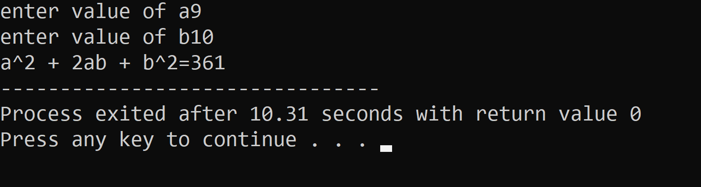

TASK 4
#include<iostream>
using namespace std;
int main()
{
double c,f;
cout<<"enter temperature in fahrenheit";
cin>>f;
c=(5*(f-32))/9;
cout<<"temperature in celcius is"<<c;
return 0;
}
